1. Navigate to [www.ncdc.noaa.gov/cdo-web/](http://www.ncdc.noaa.gov/cdo-web/)
2. Click on SEARCH TOOL

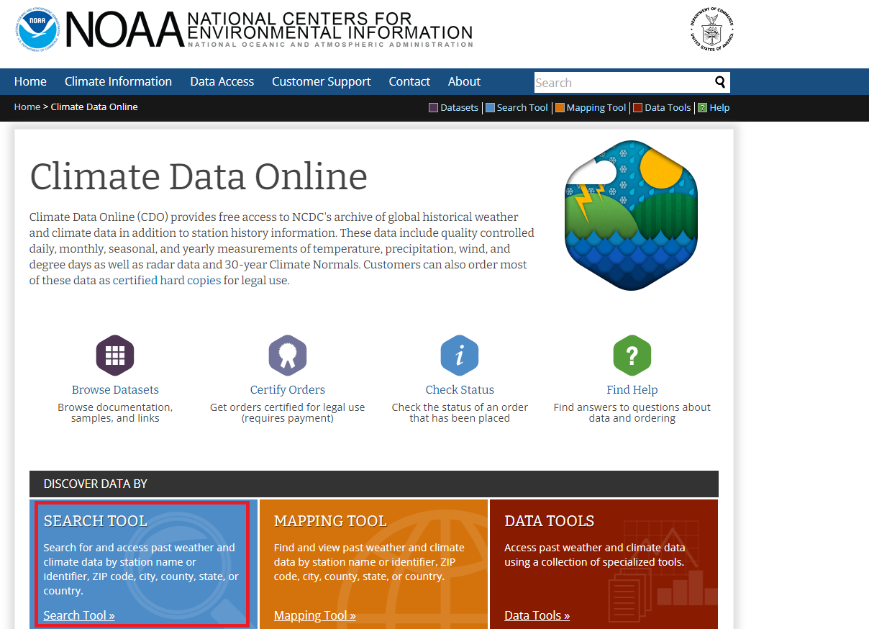

1. Select: Daily Summaries, and the time range 01/01/2018—12/31/2019. Enter New York as a search term, and click SEARCH

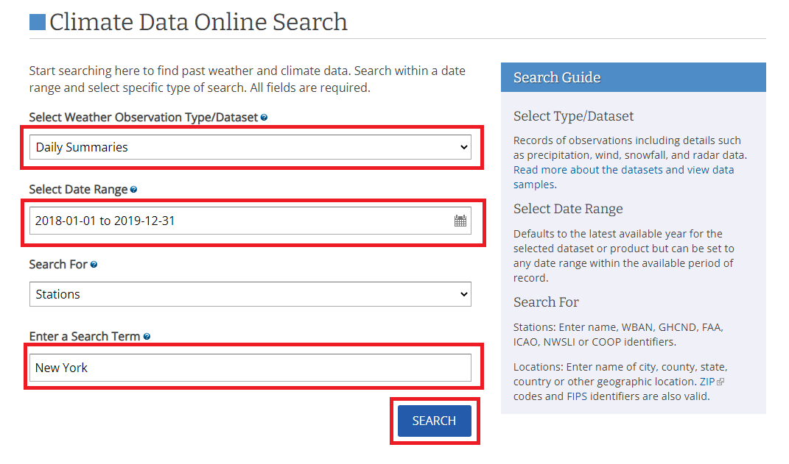

1. Find the JFK INTERNATIONAL AIRPORT dataset, and click ADD TO CART

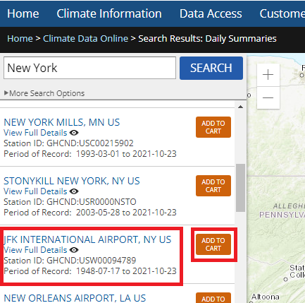

1. Click on Cart

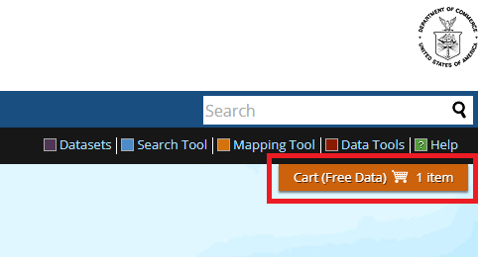

1. Select Custom GHCN-Daily CSV, and click CONTINUE

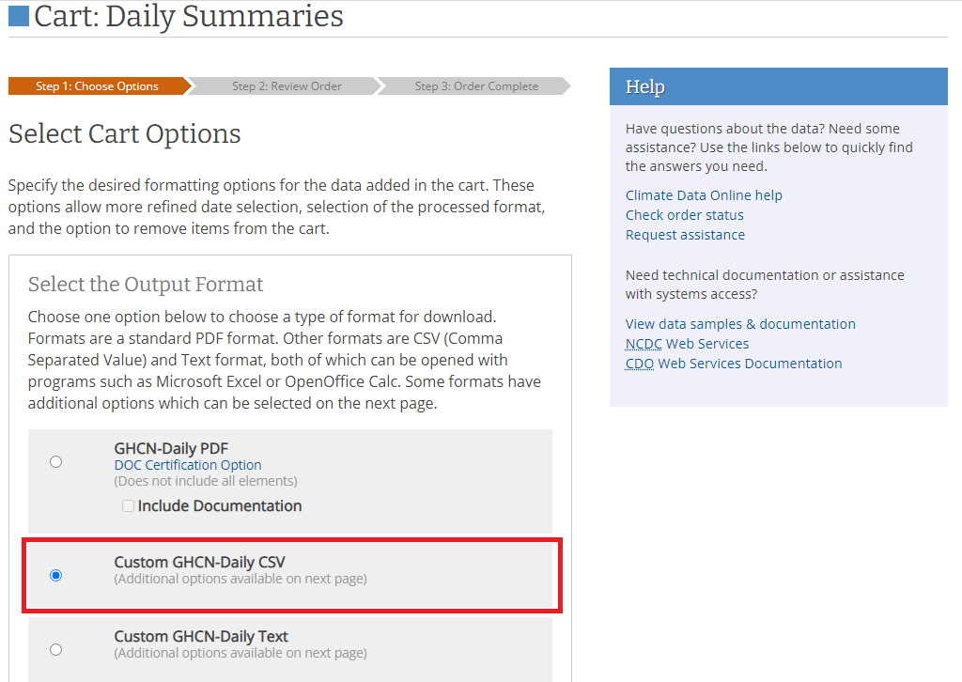

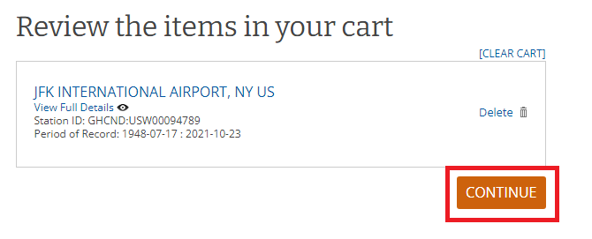

1. Select all data types, and click CONTINUE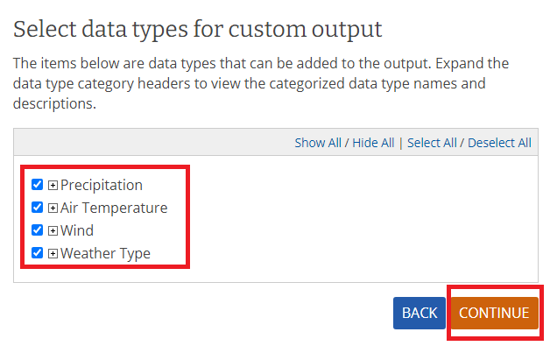
2. Enter your email address, and click SUBMIT ORDER 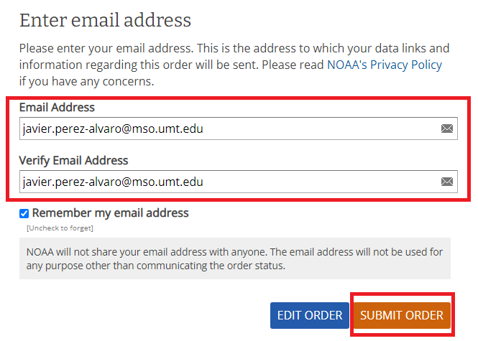
3. Open your email, and download the data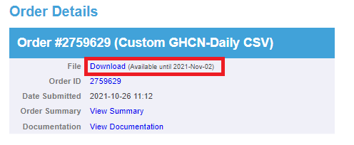
4. Rename the file to “weather_NYC”